Distance from home to bed (all detentions and admissions)
- There has been a small increase over time in mean distance CYP are admitted from home. This is accompanied by a decreasing trend in admissions numbers suggest capacity issues.
- The median distance however is constant over time, suggesting then an increase in mainly the furthest distances are skewing the mean.
- The population groups most affected (in relative terms) by increased distance from home are males, those aged 18-24, those in ‘other’ minority ethnic groups and those in deprived populations.
- Deprived populations however on average travel smaller distances due to proximity to services.
- As expected, more urban ICB areas have lower average distances from inpatient beds to home than rural ICBs. The distances are increasing for rural areas however suggesting greater access/capacity challenges in those places and more CYP travelling out of area.
Distance from home to bed (all detentions and admissions)
- For CYP, there has been a small increase (up 7%) since 2017/18 in the average distance between admission site and their home. This is accompanied by a decreasing (down 10%) in the total number of CYP admissions suggest capacity issues.
  - We don’t know from the data that it’s capacity – it could be reduced demand, centralisation of services, a combination of variables …
- However, the median distance remains constant over time, indicating that the increase in the mean is primarily driven by a rise in the furthest distances.
- The population groups that have seen the greatest percent change over the time period – relative to the average distance they travelled in 2017/18 – includes: males, those aged 18-24, those in ‘other’ minority ethnic groups and those in the most deprived IMD decile (though closely followed by those in the least deprived quintiles).
- Deprived populations however on average travel smaller distances due to proximity to services.
  - Do we know this is the reason though?
- As expected, more urban ICB areas have a generally lower average distances from inpatient beds to home than rural ICBs but this varies considerably between ICBs. The distances are increasing for rural areas however suggesting greater access/capacity challenges in those places and more CYP travelling out of area.
- The most rural ICBs are not the ones with the greatest percent change though … 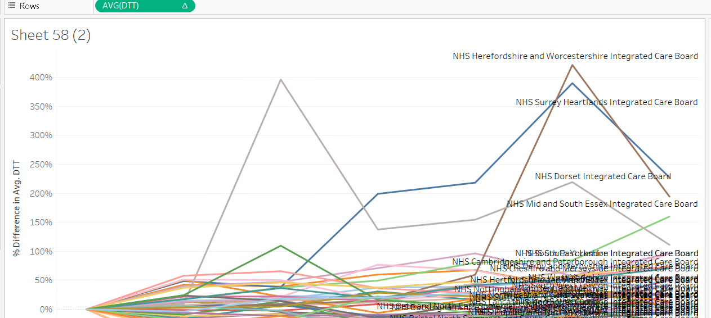
- And some that are really rural saw a decrease in their avg dtt over time:
